AUTOMATIC ENGINE LOCKING SYSTEM
An Project Report Submitted to Department of

ELECTRONICS AND COMMUNICATION ENGINEERING
In Partial Fulfillment of theRequirements For
award of the degree of

BACHELOR OF TECHNOLOGY

In
ELECTRONICS AND COMMUNICATION ENGINEERING
By
GALI VAMSHI KRISHNA
(222G1A0465)
Under the Esteemed Guidance of

Dr.P. RAMA KRISHNAVENI M.Tech.,Ph.D

Assistant Professor
ALTS, Anantapur
DEPARTMENT OF ECE

DEPARTMENT OF ELECTRONICS AND COMMUNICATION ENGINEERING
ANANTHA LAKSHMI INSTITUTE OF TECHNOLOGY AND SCIENCES
2024 - 2025
AUTOMATIC ENGINE LOCKING SYSTEM
Alcohol Detection and Tilt-Based Rollover Detection with Automatic Engine Immobilization and GSM/GPS Alerting
Project Report

ABSTRACT
This report presents the design and implementation of an Automatic Engine Locking System that immobilizes a vehicle's engine in response to two independent hazard conditions: (1) elevated alcohol concentration in the driver's breath, detected using an MQ-3 gas sensor, and (2) abnormal vehicle tilt, detected using a tilt/rollover switch. Either condition triggers the microcontroller to cut power to the engine actuation path via a motor driver, sound a buzzer, illuminate a status LED, display the condition on an LCD, and transmit the vehicle's GPS coordinates to a registered mobile number over SMS using a SIM800C GSM/GPS module. By combining impairment detection with crash/rollover detection in a single embedded platform, the system extends beyond conventional alcohol-interlock designs to also provide a rapid emergency-location alert after a rollover event, improving both drunk-driving prevention and post-accident response time.
Keywords: Engine Locking, Alcohol Sensing, Tilt Sensor, Rollover Detection, Arduino, STM32 HAL, MQ-3 Sensor, GSM, GPS.

I. INTRODUCTION
Road traffic accidents remain a leading cause of preventable death worldwide, with driver impairment and loss of vehicle control both contributing significantly to fatal and severe-injury crashes. Drunk driving continues to account for a substantial share of these incidents despite legal blood-alcohol-concentration (BAC) limits, enforcement checkpoints, and public-awareness campaigns. Separately, single-vehicle rollover and tip-over events -- caused by sharp maneuvers, uneven terrain, or collisions -- often leave occupants unable to call for help, making rapid, automatic notification of emergency contacts critical to survival outcomes.
This project addresses both risk categories within one embedded system. An MQ-3 semiconductor gas sensor continuously monitors alcohol vapor concentration near the driver; if it exceeds a calibrated threshold, the system infers possible impairment and locks the engine before the vehicle can be operated. Independently, a tilt/rollover switch monitors the vehicle's orientation; a sustained tilt beyond a safe angle is treated as a likely accident, triggering the same engine-lock response together with an emergency SMS containing the vehicle's GPS coordinates. Combining both triggers in a single controller keeps the hardware footprint and cost low while covering two of the most common causes of preventable road fatalities.

A. Objectives
- Detect elevated alcohol concentration in the driver's breath in real time using the MQ-3 sensor.
- Detect abnormal vehicle tilt or rollover using a dedicated tilt sensor, independent of the alcohol-detection path.
- Automatically immobilize the engine when either hazard condition is detected.
- Provide immediate audible and visual alerts (buzzer, LED, LCD) to the driver and occupants.
- Transmit the vehicle's live GPS location via SMS to a registered contact for rapid intervention.
- Allow manual reset/override once the hazard condition has been resolved (e.g., a sober driver takes over).

II. BLOCK DIAGRAM
Figure 1 shows the system's block diagram. Two independent sensing inputs -- the MQ-3 alcohol sensor and the tilt sensor -- along with the manual reset button, feed into the central microcontroller. The microcontroller evaluates both sensor paths every sampling interval and drives four output blocks: the LCD status display, the buzzer/LED alert pair, the motor driver that actuates the engine lock, and the SIM800C GSM/GPS module that sends the SMS location alert. A regulated power supply feeds the microcontroller and, in turn, every other block in the system.
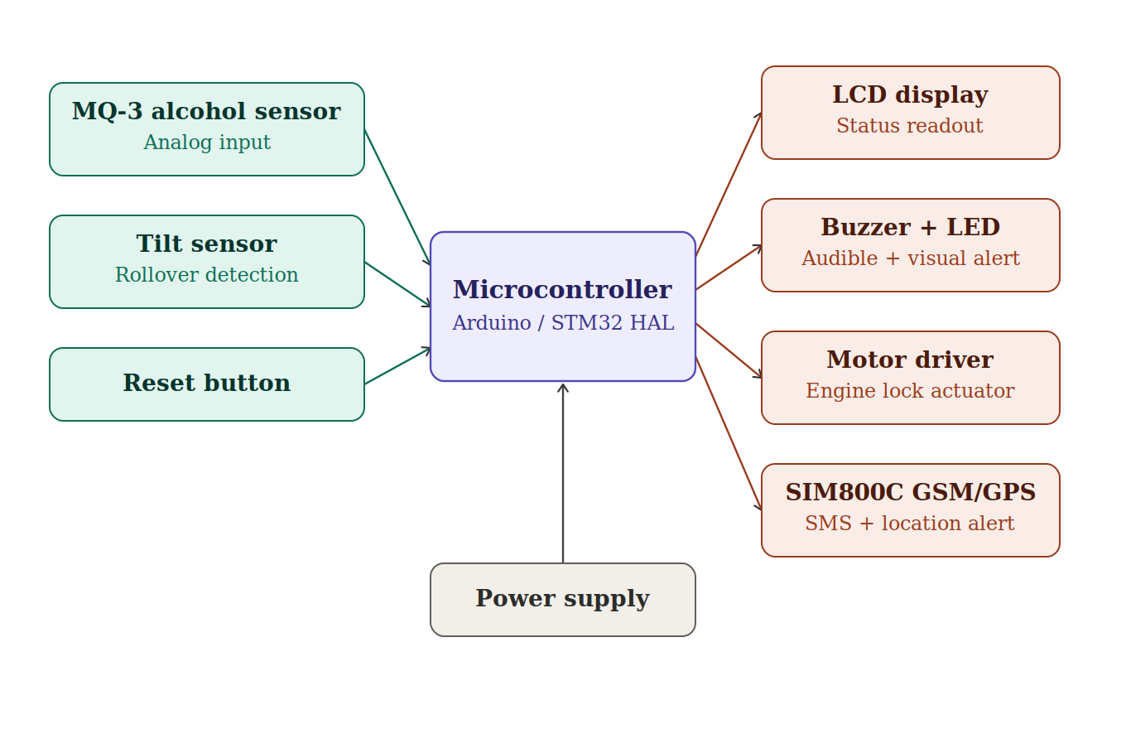
Figure 1: Block Diagram of the Automatic Engine Locking System
Table 1 below details each block's interface, key specification, and role within the overall system, expanding on the summary shown in the diagram.
Block | Interface | Specification | Role in the System
Microcontroller | Central / all blocks | Arduino UNO (ATmega328P, 14 digital I/O, 32KB flash) or STM32 HAL target (ADC, TIM PWM, I2C, USART peripherals) | Runs the detection algorithm; reads both sensors every sampling interval and drives all outputs
MQ-3 alcohol sensor | Analog input (ADC) | Tin-oxide semiconductor gas sensor; analog voltage output proportional to alcohol vapor concentration | Provides the raw alcohol reading that is averaged and compared against a calibrated threshold
Tilt sensor | Digital input (GPIO) | Ball-and-ring or mercury tilt switch (e.g. SW-520D); active-low digital contact, wired with pull-up | Signals when the vehicle's inclination exceeds a safe angle; debounced over several samples
Reset button | Digital input (GPIO, pull-up) | Momentary push button, active low | Manually re-enables the engine after an alert has been resolved
Motor driver + DC motor | Digital outputs + PWM | H-bridge driver (e.g. L298N) with direction pins and a PWM-controlled enable line | Actuates / simulates the relay that immobilizes the engine when a hazard is detected
LCD display | Parallel (4-bit) or I2C | 16x2 character LCD, direct parallel wiring (Arduino) or PCF8574 I2C backpack (STM32 HAL) | Shows live sensor readings and the current system status to the driver
Buzzer + status LED | Digital outputs (GPIO) | Piezo buzzer and a single indicator LED | Provide immediate audible and visual alerts when a hazard condition is detected
SIM800C GSM/GPS module | UART, 9600 baud | Quad-band GSM/GPRS with optional onboard GNSS (AT+CGNSINF); external GPS module supported as an alternative | Sends an SMS alert with a GPS location link to a registered mobile number
Power supply / regulator | Feeds all blocks | Regulated 5V (Arduino logic) or 3.3V (STM32 logic) rail, plus a separate 3.7-4.4V high-current supply for the SIM800C | Provides stable, adequately rated power to every subsystem
Table 1: Block Diagram Components and Specifications

III. METHODOLOGY

A. System Design and Component Selection
The system architecture integrates a microcontroller (implemented in both an Arduino UNO version and an STM32 HAL version) with two independent sensing subsystems -- an MQ-3 alcohol sensor and a digital tilt switch -- alongside a motor-driver-actuated engine lock, an LCD status display, a buzzer, a status LED, a manual reset button, and a SIM800C GSM/GPS module for remote alerting. Component selection prioritized low cost, wide availability, and proven reliability in embedded automotive prototyping.
# | Component | Function in the System
1 | Arduino UNO / STM32 MCU | Central controller; reads sensors, runs detection logic, drives outputs
2 | MQ-3 Alcohol Sensor | Detects alcohol vapor concentration in the cabin/driver's breath
3 | Tilt Sensor (SW-520D / mercury switch) | Detects vehicle tilt or rollover beyond a safe angle, e.g. after a crash
4 | DC Motor + Motor Driver (H-bridge) | Simulates/actuates the engine-immobilization relay
5 | 16x2 LCD Display | Shows live sensor readings and system status to the driver
6 | Buzzer | Audible alert on alcohol or tilt detection
7 | Status LED | Visual indicator of an active alert/lock condition
8 | SIM800C GSM/GPS Module | Sends SMS alerts with GPS location coordinates to a registered number
9 | Push Button (Reset) | Manual override to re-enable the engine after an alert is resolved
10 | Voltage Regulator / Power Supply | Provides regulated power to all subsystems
Table 2: System Components and Their Functions

B. Hardware Integration and Assembly
The MQ-3 sensor's analog output is wired to an ADC input channel; the tilt switch's digital output (active-low, pulled up) is wired to a dedicated GPIO input. Both are sampled on the same periodic cadence by the main control loop. The motor driver's direction pins and PWM enable line are wired to GPIO/timer outputs and stand in for the relay that would, in a full vehicle integration, interrupt the starter or ignition circuit. The LCD is driven either in 4-bit parallel mode (Arduino version) or over I2C via a PCF8574 backpack (STM32 HAL version). The SIM800C communicates with the controller over a UART at 9600 baud and is powered from a separate regulated supply capable of handling its transmit-current spikes.

C. Detection and Control Algorithm
Every sampling interval, the controller reads an averaged alcohol level from the MQ-3 sensor and polls the tilt switch through a debounce filter that requires several consecutive tilted readings before registering a detection -- this rejects false triggers from potholes or hard gear changes. If a tilt event is confirmed, it takes priority and immediately locks the engine, since a rollover represents an active emergency. If no tilt is present but the alcohol level exceeds the calibrated threshold, the engine is locked via the alcohol-detection path instead. In both cases, the buzzer and status LED activate, the LCD updates to show the specific condition, and -- rate-limited by a cooldown timer to avoid flooding the network -- an SMS alert containing the GPS location (via AT+CGNSINF on the SIM800C, or a companion GPS module's NMEA output) is sent to the registered number. A physical reset button allows the engine to be re-enabled once the hazard has passed.

D. Testing and Validation
The system was tested under four scenarios: alcohol-only detection, tilt-only detection, combined detection, and the normal/no-hazard baseline, in addition to verifying the manual reset path. Expected behavior for each case is summarized below.
Test Condition | Engine State | Alerts | GSM Action
Alcohol only (above threshold), no tilt | Locked | Buzzer + LED ON | SMS with location sent
Tilt only (vehicle rolled/tipped) | Locked | Buzzer + LED ON (double-beep) | SMS with location sent
Both alcohol and tilt present | Locked (tilt path takes priority) | Buzzer + LED ON | SMS with location sent
Neither condition present | Running / unlocked | OFF | No SMS sent
Manual reset pressed after alert | Re-enabled (running) | OFF | No SMS sent
Table 3: Test Scenarios and Expected System Behavior

IV. MODELING AND ANALYSIS
On activation, the controller initializes all peripherals and begins acquiring readings from the MQ-3 sensor and the tilt switch on a fixed sampling interval. Sensor data is compared against predefined thresholds; a tilt event is confirmed after a debounce window of consecutive tilted samples, while the alcohol level is averaged over several ADC reads to reduce noise. Either confirmed condition triggers the engine-lock sequence: the motor driver's enable line is de-energized, the buzzer and LED activate, and the LCD is updated. The GSM/GPS module is then queried for a location fix and, subject to a cooldown to prevent SMS flooding, an alert is transmitted to the registered contact. This control flow was implemented twice -- once as a single-file Arduino sketch for rapid prototyping, and once as a modular STM32 HAL project with one driver file per subsystem (alcohol sensor, tilt sensor, engine lock, buzzer/LED, LCD, and GSM/GPS) for a more production-oriented structure.

1. Tilt Sensor Module
The tilt sensor is a mechanical ball-and-ring or mercury switch (e.g. SW-520D) that closes or opens a digital contact once the vehicle's inclination exceeds the switch's built-in mechanical angle. Wired with a pull-up resistor, the pin reads LOW when tilted. Because vibration and normal road undulation can cause brief, spurious closures, the firmware requires several consecutive tilted samples (a debounce count) before treating the event as a genuine rollover, striking a balance between responsiveness and false-alarm rejection.

2. Alcohol Sensor Module
The MQ-3 tin-oxide semiconductor sensor changes electrical conductivity in the presence of alcohol vapor, producing an analog voltage proportional to concentration. The controller averages several consecutive ADC samples to smooth sensor noise before comparing against a threshold calibrated for the specific sensor unit and supply voltage.

3. Engine Lock Actuation
A DC motor driven through an H-bridge motor driver stands in for the relay or solenoid that would interrupt a real vehicle's starter or fuel-injection circuit. 'Engine running' corresponds to the motor being driven; 'engine locked' corresponds to the enable line being de-energized, cutting all drive to the motor.

4. GSM/GPS Alerting
The SIM800C module provides both cellular SMS capability and, where supported by its firmware, an onboard GNSS receiver queried via the AT+CGNSINF command. The controller parses the returned latitude/longitude fields into a Google Maps URL and appends it to an SMS describing which hazard condition (alcohol or tilt) triggered the alert, giving the recipient both the nature of the emergency and its precise location.

V. RESULTS AND DISCUSSION
When alcohol concentration exceeds the calibrated threshold, the system reliably shuts down the engine, sounds the buzzer, and updates the LCD within one sampling cycle, while the GSM module dispatches a location-tagged SMS to the registered contact. In tilt-simulation testing, tipping the sensor assembly beyond its mechanical threshold for the debounce window consistently triggered the same immobilization and alerting sequence, distinguished on the LCD and in the SMS text as a tilt/rollover event rather than an alcohol event. The debounce logic successfully rejected brief, incidental jolts during bench testing without missing sustained tilt conditions. Adding the tilt sensor did not interfere with the alcohol-detection path's response time, since both are polled independently within the same control loop iteration, with tilt given priority when both conditions are simultaneously present, reflecting its higher-urgency, accident-indicating nature.

VI. ADVANTAGES
- Dual-hazard coverage: addresses both impairment-related and accident-related risks in one low-cost platform.
- Fast automatic response: no reliance on the driver or occupants to manually call for help after a rollover.
- Location-aware alerting: GPS coordinates included in every SMS accelerate emergency response.
- Debounced tilt detection reduces false alarms from ordinary road conditions.
- Manual override supports legitimate re-enabling of the vehicle once a hazard is resolved.
- Portable design: implemented on both Arduino (rapid prototyping) and STM32 HAL (production-style modular firmware).

VII. LIMITATIONS AND FUTURE SCOPE
The MQ-3 sensor requires periodic recalibration and is sensitive to environmental factors such as humidity and temperature, which can affect threshold accuracy over time. The tilt switch provides a binary tilt/no-tilt signal rather than a continuous angle measurement; replacing it with a 3-axis accelerometer/gyroscope (e.g., an MPU6050) would allow finer-grained rollover detection and could additionally support impact/collision detection via sudden deceleration sensing. Future work could also integrate a dedicated crash-impact sensor, cloud-based fleet logging of alert events, and a mobile companion app for real-time monitoring by family members or fleet operators.

VIII. CONCLUSION
The Automatic Engine Locking System demonstrates a practical, low-cost embedded solution that combines alcohol-impairment detection with tilt-based rollover detection to immobilize a vehicle's engine and alert a registered contact with the vehicle's live location. By extending a conventional alcohol-interlock design with an independent tilt-sensing path, the system broadens its protective scope beyond drunk-driving prevention to include faster emergency response after a rollover incident, contributing to improved road safety outcomes. The modular firmware structure -- available in both an Arduino implementation and a modular STM32 HAL implementation -- makes the system straightforward to extend with additional sensors or communication channels in future iterations.

IX. REFERENCES
[1] Yadaiah, K., Chandana, C., Annapurna, B. "Alcohol Sensing Alert with Engine Locking Using IoT," 2022.
[2] Kumar, B. Manoj, Kumar, M. Prasanna, Kumar, G. Anil. "Alcohol Sensing Alert with Engine Locking," 2022.
[3] Bade, Anjali, Patil, Jui, Kanase, Shradha. "GPS Tracker and Alcohol Detector with Engine Locking System Using GSM," 2023.
[4] Prasad, Avagaddi; Pavankalyan, Janapamula; Sai Ganesh, Alapati; Krishna, Kakileti Murali. "Drowsiness And Alcohol Detection with Engine Locking," IEEE, 2022.
[5] Babor, T. AUDIT: The Alcohol Use Disorders Identification Test: Guidelines for Use in Primary Health Care. Geneva, Switzerland: World Health Organization, 1992.
[6] Kumudham, R., Valentina, Jessica, Ragavi, B., Lakshmi, R. "Automatic Alcohol Detection and Engine Locking System using ARDUINO NANO," Journal of Applied Science and Computations (JASC), ISSN: 1076-5131.
[7] Cahalan, D., Cisin, I., Crossley, H. American Drinking Practices: A National Study of Driving Behaviour and Attitudes. New Brunswick, NJ: Rutgers University Press, 1969.

--------------------------------------****************************************---------------------------------------

